POWERSCHOOL ENROLLMENT EXPRESS – SEVEN STEP PROCESS

Step 1.
Visit https://ecollect.accelaschool.com/lnsu to begin the enrollment process.
Fill out all required fields.

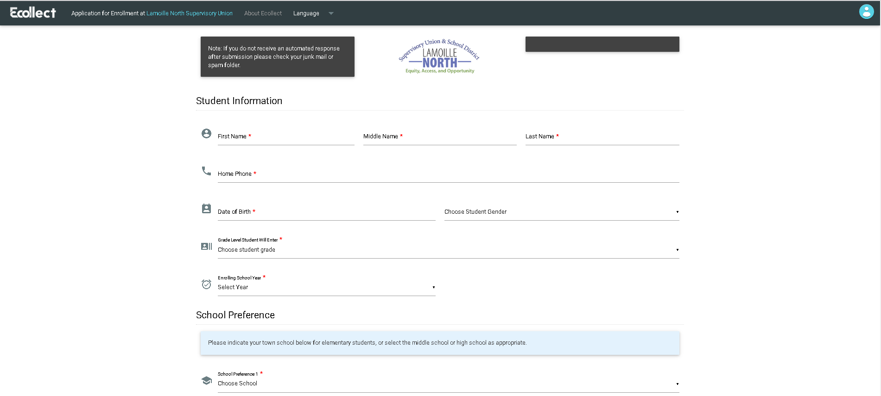
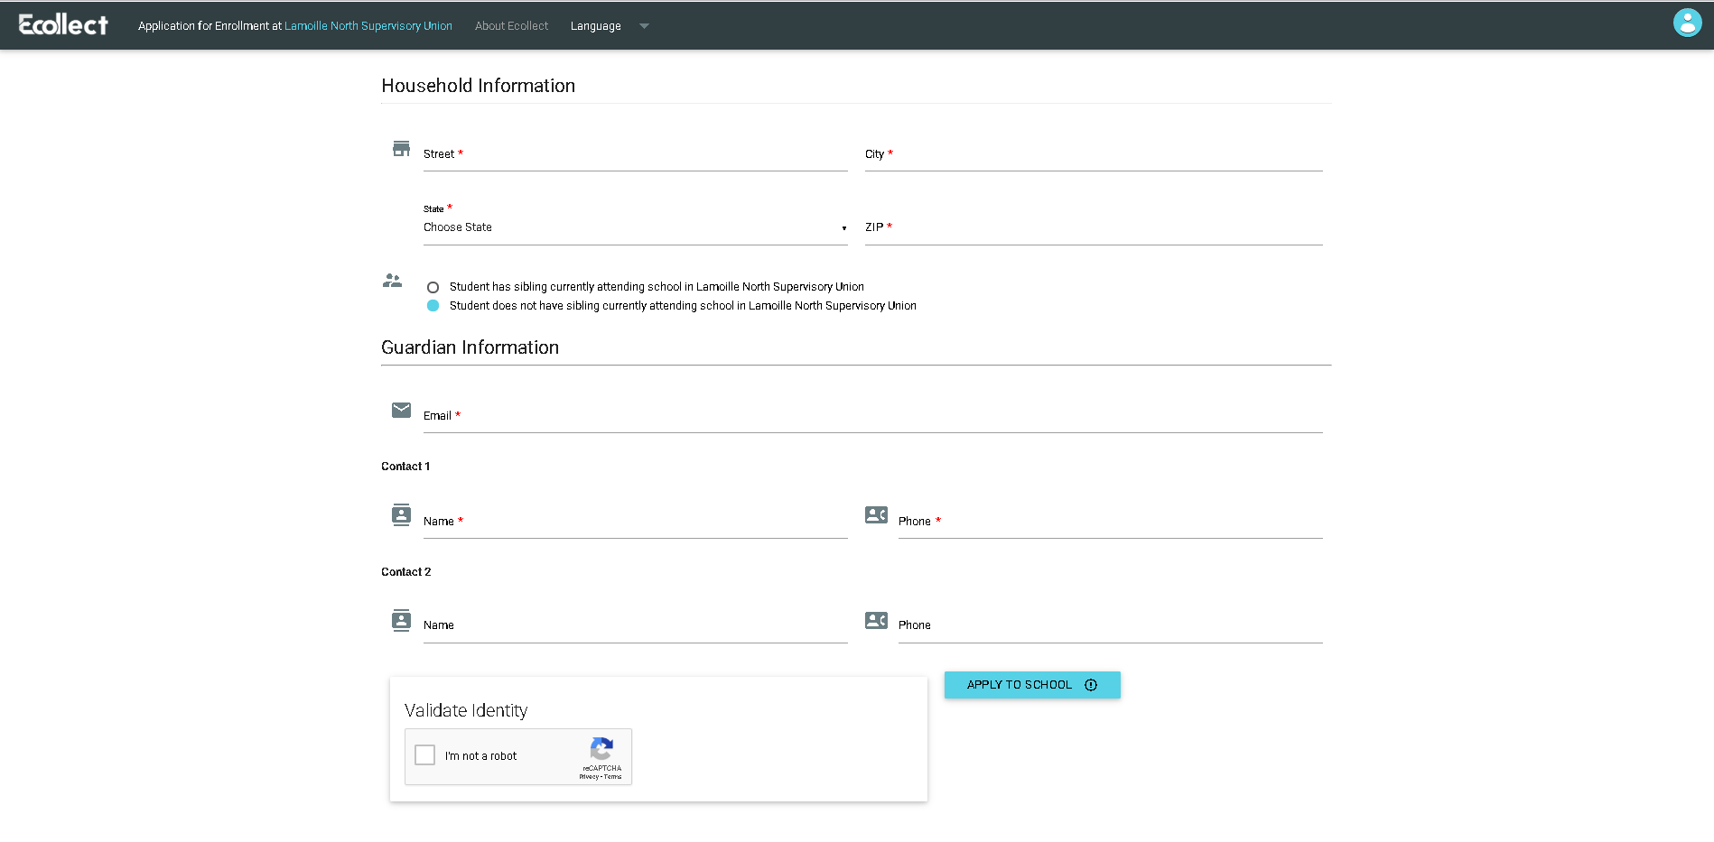

Step 2.
Upon successful submission and entering in a valid email, the parent will receive an automated response. The application is now awaiting review by the registrar based on the school selected.

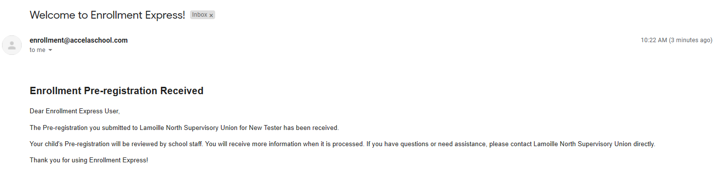

Step 3.
Once a registrar has reviewed the information you presented, verified info, and made any necessary calls to you the registration can be approved. Once the registration is approved you will receive notification.

Please proceed to step 4 for additional information.

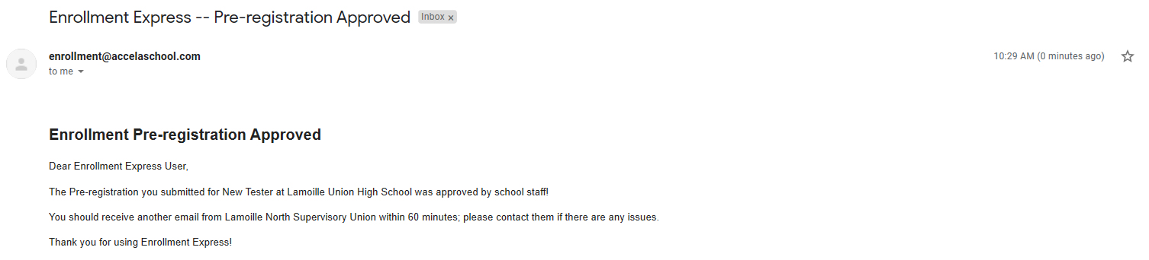

Step 4.

Once the application has been reviewed and approved by the school registrar, the Guardian will receive an email stating their Powerschool account has been created. The email comes from Powerschool@luhs18.org.
Please keep in mind Step 4 is different for existing parents that already have a Powerschool sign-in. We offer instruction below for existing parents with Powerschool Accounts and for new to Powerschool parents.

Hello,
Your preliminary enrollment information has been received. Your next step is to create a Powerschool parent account, unless you already have one. After the account is created, you may log in and complete a few forms to finish your student’s registration.
I NEED TO SET UP A NEW ACCOUNT!
1. Please go to the PowerSchool website at http://lnsu.powerschool.com
2. Click Create Account (not 'Sign In')
3. Fill in the information required at the top of the screen
4. Create your own User Name and Password (number and letters only for both)
5. Fill in your student's name (see below)
6. Fill in your Parent/Guardian Access ID and Access Password for this student (see below)
7. Select your relationship to the student (e.g. mother, father, etc.)
8. Click Enter
I NEED TO ADD A STUDENT TO MY ACCOUNT
1. Please go to the PowerSchool website at http://lnsu.powerschool.com, Log in and click on "Account Preferences." If you forgot your password, simply click on the “Forgot Username or Password” link.
2. Then, click on the "Students" tab. All of your current students will be displayed.
3. To add one or more to your account, click on the "Add" button. Enter the student's name, Access ID, Access Password (below), and your relationship to your student (Mother, Father, etc.).
4. Click on "OK" to submit. This should add their name to the blue bar on your page.
5. Click on your added student's name in the blue bar to access their information
Thank-you for providing all of this critical information so that we can prepare a smooth experience into our school for your student.
Date and Time: 08/10/2020 09:30:51 am
Access ID: (your email will contain a unique one-time use Access ID for your child)
Access Password: (your email will contain a unique one-time use Access Password for your child)
Student Name: (Your child’s name)
PowerSchool Address: https://lnsu.powerschool.com/public
Disclaimer: This is an automated message generated by Enrollment Express system. This email and any files transmitted with it are confidential and intended solely for the use of the individual or entity to whom they are addressed. If you have received this email in error please notify the system manager. This message contains confidential information and is intended only for the individual named. If you are not the named addressee you should not disseminate, distribute or copy this e-mail. Please notify the sender immediately by e-mail if you have received this e-mail by mistake and delete this e-mail from your system. If you are not the intended recipient you are notified that disclosing, copying, distributing or taking any action in reliance on the contents of this information is strictly prohibited.
Sent on behalf of noreplyregistration@lnsd.org

***Please note you will have to verify your new PowerSchool Email before you can sign in

Step 5.
Before logging in you will have to verify your PowerSchool Account Email. A message will be sent to your email account. You must click on the link to verify your identity and proceed.

Step 6.
After log in, the system will begin at the dashboard page. It will look similar to this view.

Please click on “Forms” near the bottom of the left menu to begin.

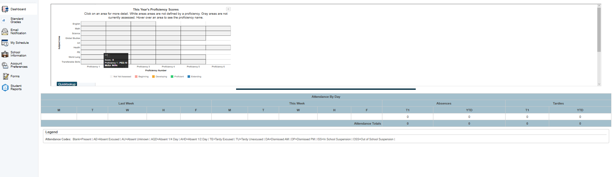

Step 7.
You are now in the forms sections. Begin with the “Demographics” form. When you finish, the “Student Contacts” form will open, then Previous Enrollments, Residency Verification, Home Language Survey and LNSD Release forms. PreK parents/guardians must fill out the 2021-2022 School Year Act 166 form as well.

-More forms are added to aid schools in collection of student information so the view is subject to change.
-Each parent is able to save his or her spot and come back later to finish.
-The green status bars indicate a form or forms are complete. Conversely, the red status bars indicate a form or forms are incomplete.

The parent or guardian is required to fill out all PowerSchool forms to complete the registration process.

New registrations need to upload proof of residency as part of the Residency Verification form.

Please view the Optional Forms section. Please acknowledge the form if not applicable.

Pre-K only applies to a select few. Please use the current school year form.

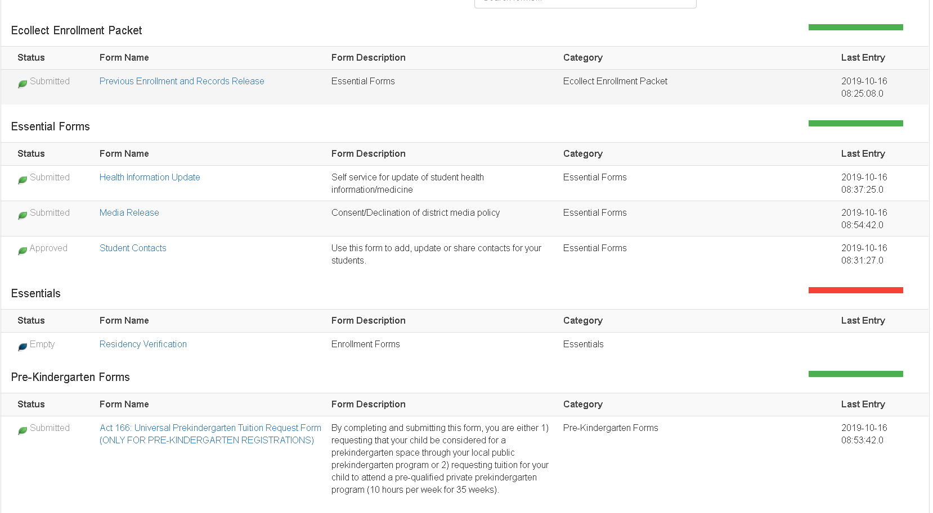

If there are any questions, the school registrar will contact the applicant and make any necessary changes as needed. If you need to reach a school registrar please send an email.

LNSU Registrars
Lisa Vanat – ECS – lvanat@edenschool.net
Darcey Fletcher – LUMS – dfletcher@luhs18.org
Jean Santamaria – GMTCC – jsantamaria@gmtcc.net
Beth Brown – CES – bbrown@cesvt.net
Karen Aither – HPES – kaaither@hpes.org
Christine Cooney – LUHS – ccooney@luhs18.org
Janet Davis – JES – jdavis@jesvt.org
Deb Arel – WES/BCS – darel@wesvt.net

